Q6. Understand how to access remote system using (VNC viewer, Anydesk, teamviewer and remote desktop connections)

VNC Viewer: **Virtual Network Computing (VNC) Viewer** is a **remote desktop protocol** that allows users to access and control another computer over a network using a **graphical interface**. It operates using the **RFB (Remote Framebuffer) protocol** to transmit screen updates and capture user inputs.

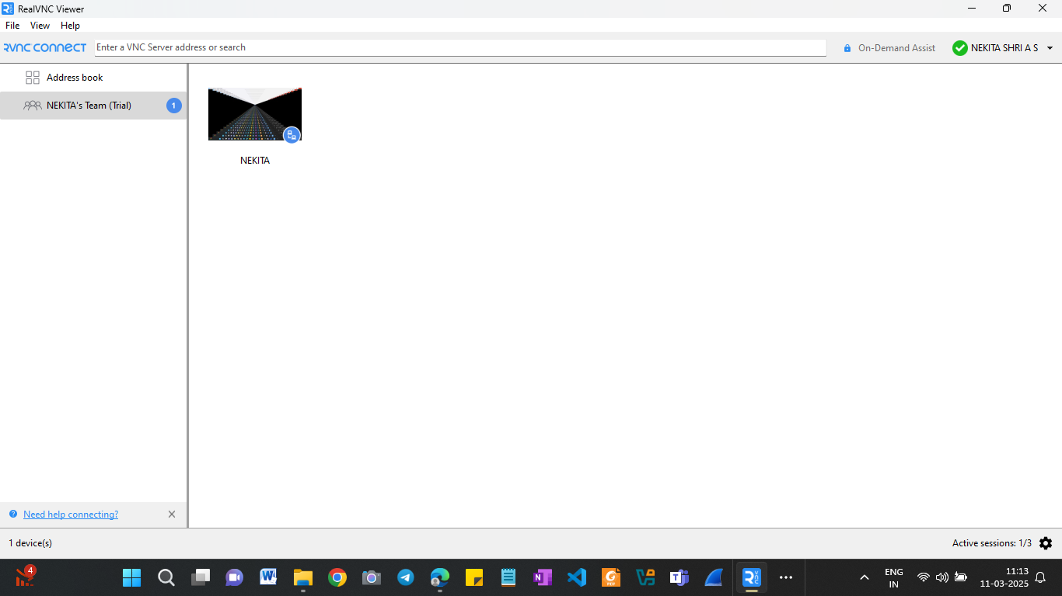

Anydesk: A **remote desktop application** that enables fast, secure, and low-latency access to computers over the internet. It is widely used for **remote support, IT administration, and collaborative work**. Unlike traditional RDP or VNC, AnyDesk is designed to be **lightweight and optimized for speed** with **low bandwidth consumption**.

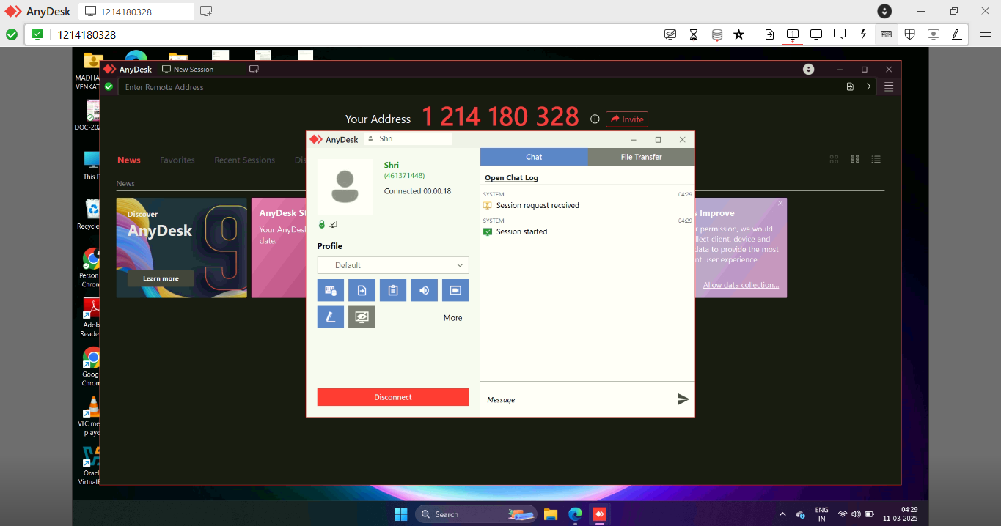

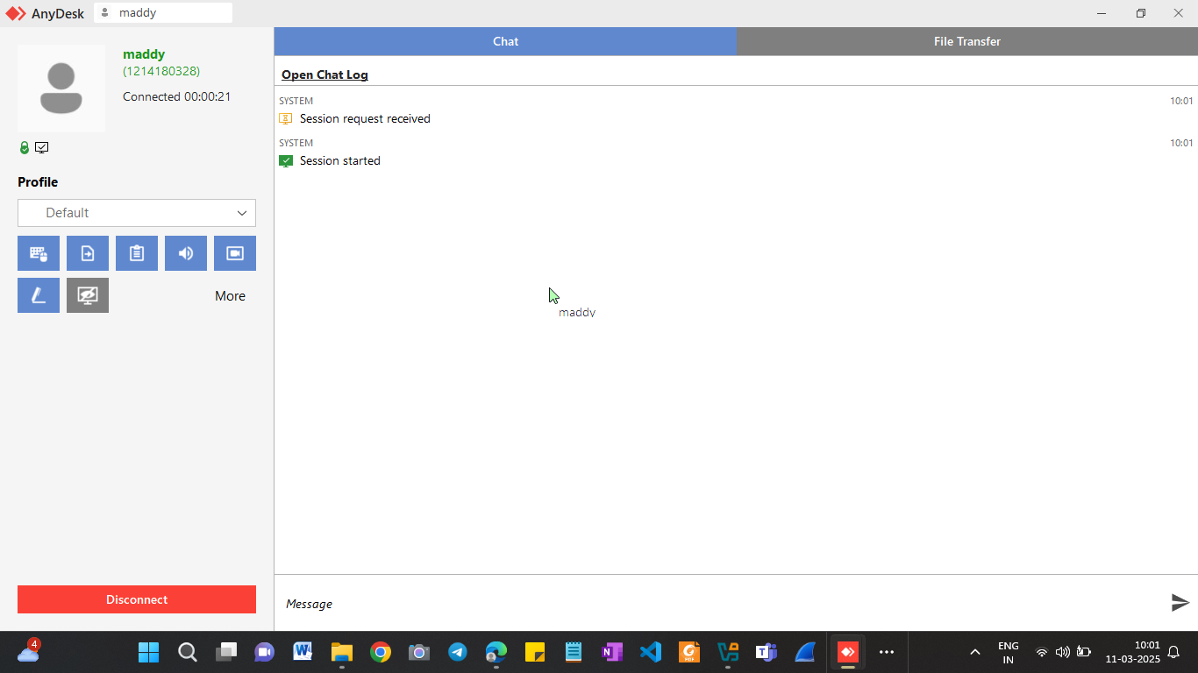

3)Teamviewer: enables users to **control, troubleshoot, and access remote devices** over the internet. It is widely used in IT support, remote work, and collaborative environments. TeamViewer supports **cross-platform access**, allowing connections between **Windows, macOS, Linux, Android, iOS, and even IoT devices**.

